Undergraduate students at Plymouth University and University of Liverpool
By Megan Dalton (@MegConsBio) and Eddie Font Freide (@Eddie_Eco)

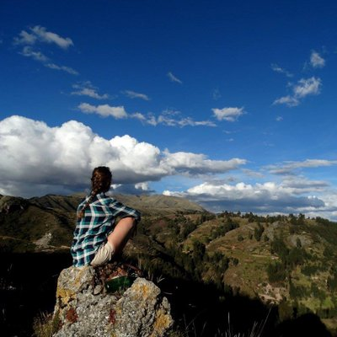
This year about 70 students attended the Third BES Summer School. We were a mix of ages, with people just finishing their first year of university straight after sixth form, to mature students who had done other degrees and been in the ‘real’ world. This meant there was a whole host of different experiences and stories to be shared, but due to our shared interest in ecology there was always a discussion to be had, especially on the topics covered throughout the week. If you’re looking for diversity within ecology then look no further, in a week we covered Entomology, Forensic Ecology, UV Invertebrate tracking, R stats and much, much more. Eddie and I both wanted to share our favourite experiences and what we gained most from the week to give you a flavour of what you could gain from the BES Summer School.
I applied to the BES Summer School in my first year, thinking there would be many more experienced students applying. However, much to my delight I received an email saying I had succeeded in gaining a place. I was soon put in touch with my PhD mentor; Melanie. For me she is one of the best things I have gained from this experience; someone who has been in my position not too long ago and is happy to receive constant CV updates, stage mock interviews with me and just be there to answer questions in general. The same goes for the other PhD mentors who attended, some of the most helpful conversations I had were over meal times or in the evening. If, like me, you don’t have a specific area you want to specialise in, then talking to these guys really helps in planning a year in industry or dissertation project.
For me the most enjoyable part was being able to dip my toes into so many areas of ecology. As someone who has enjoyed everything I’ve covered in my first-year modules being able to gain practical experience in a range of areas outside my university programme was great. Although it simply broadened the number of subjects I enjoyed, it also gave me a view of where I could be and what I could be doing in a few years’ time. One highlight for me was our first plenary speaker, Prof. Jane Memmott with her wonderful stories about her career journey from parasitic wasps in Hawaii to UK cities being beneficial for bumblebees. This was the first moment it clicked for me that you don’t have to ‘loose out’ on working in an area, there are ways to work holistically in ecology as Professor Memmott does with food webs. This idea that I could work in many different areas through gaining transferable skills was confirmed by talking to other PhD mentors and guest lecturers, allowing me to develop ideas for both a year in industry and my dissertation project. On top of this being in the environment of the Summer School gave me a fantastic network for gaining contacts and recommendations of where to apply and who to get in touch with.
In addition to valuable skills and contacts, the BES also provides the perfect opportunity to get involved in things beyond the normal university curriculum such as trapping and identifying almost 50 moths, covering beetles in UV powder and following them with UV lights, and of course the trip to Skomer island was one of everyone’s highlights. If I haven’t convinced you then read on to hear Eddie’s experience of the week!

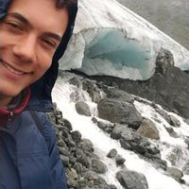
Like Megan, my experience of the summer school has given me insight into areas of ecology that I hadn’t previously considered. For example, I’d never really thought about careers in policy, and soil didn’t interest me before. Policy has now stuck in my mind as an area of ecology where I can make a difference by using my future research to inform others, which seems very rewarding. I’d like to discover more about the mysterious processes that go on in the soil, as there are so many unanswered questions about how it works. Attending the summer school has helped me broaden my horizons and consider other career paths I may otherwise never have come across.
Every activity I took part in over the course of the summer school was useful, but some things I found incredibly valuable were the opportunities to have my CV checked by the lovely PhD mentors, as well as the Pathways to a PhD talk, where the mentors explained how they ended up on their PhDs. It was great to receive feedback on our CVs people as experienced as the mentors, and the PhD talk got me thinking about doing a PhD in future. Previously I’d found the prospects of a PhD rather daunting, but the mentors swayed me to pursue my studies of ecology even further.
A highlight for me had to be Professor Jane Memmott’s plenary talk on our first night in Wales. She focused on her research interests including pollination ecology, invasion ecology and urban ecology. All her research was underpinned by the use of ecological networks to answer ecological questions, something that really fascinated me. I was inspired by how passionate Jane was about all her work, and getting to know her story about how she got to be where she is now was priceless information.
The visit to Skomer was of course another highlight of the week. I’ve been to a few places which are ‘known’ for their puffins before, but they didn’t really live up to my expectations. However, as the boat pulled into Skomer’s North Haven, we were greeted by countless numbers of puffins bobbing up and down on the sea. Walking round the island, particularly at The Wick, puffins were flying right over our heads, and boldly walking along the paths in front of us! As well as being overwhelmed by puffins, we learned about the endemic Skomer vole and spoke to researches who study the Manx Shearwater (almost half the world’s population of this seabird nests on the island!).
If you want to improve your knowledge of all things ecological and discover various career prospects that you may not have considered before, then the BES Summer School is for you. Being surrounded by the students, mentors and professionals who are all practising in the field of ecology is incredibly immersive and a fantastic way to network and share ideas. Megan and I would recommend anyone interested in ecology to apply for next year’s summer school, you have nothing to lose! Look out for emails sent around by your university, and whether you’re a first or second year, there is much to be gained from this experience!
Save the Date!
The 2018 Summer School will take place at Malham Tarn Field Studies Centre in Yorkshire on 16-20th July 2018. Applications will open January 2018 but you can add your name to mailing list by contacting the Education Officer

