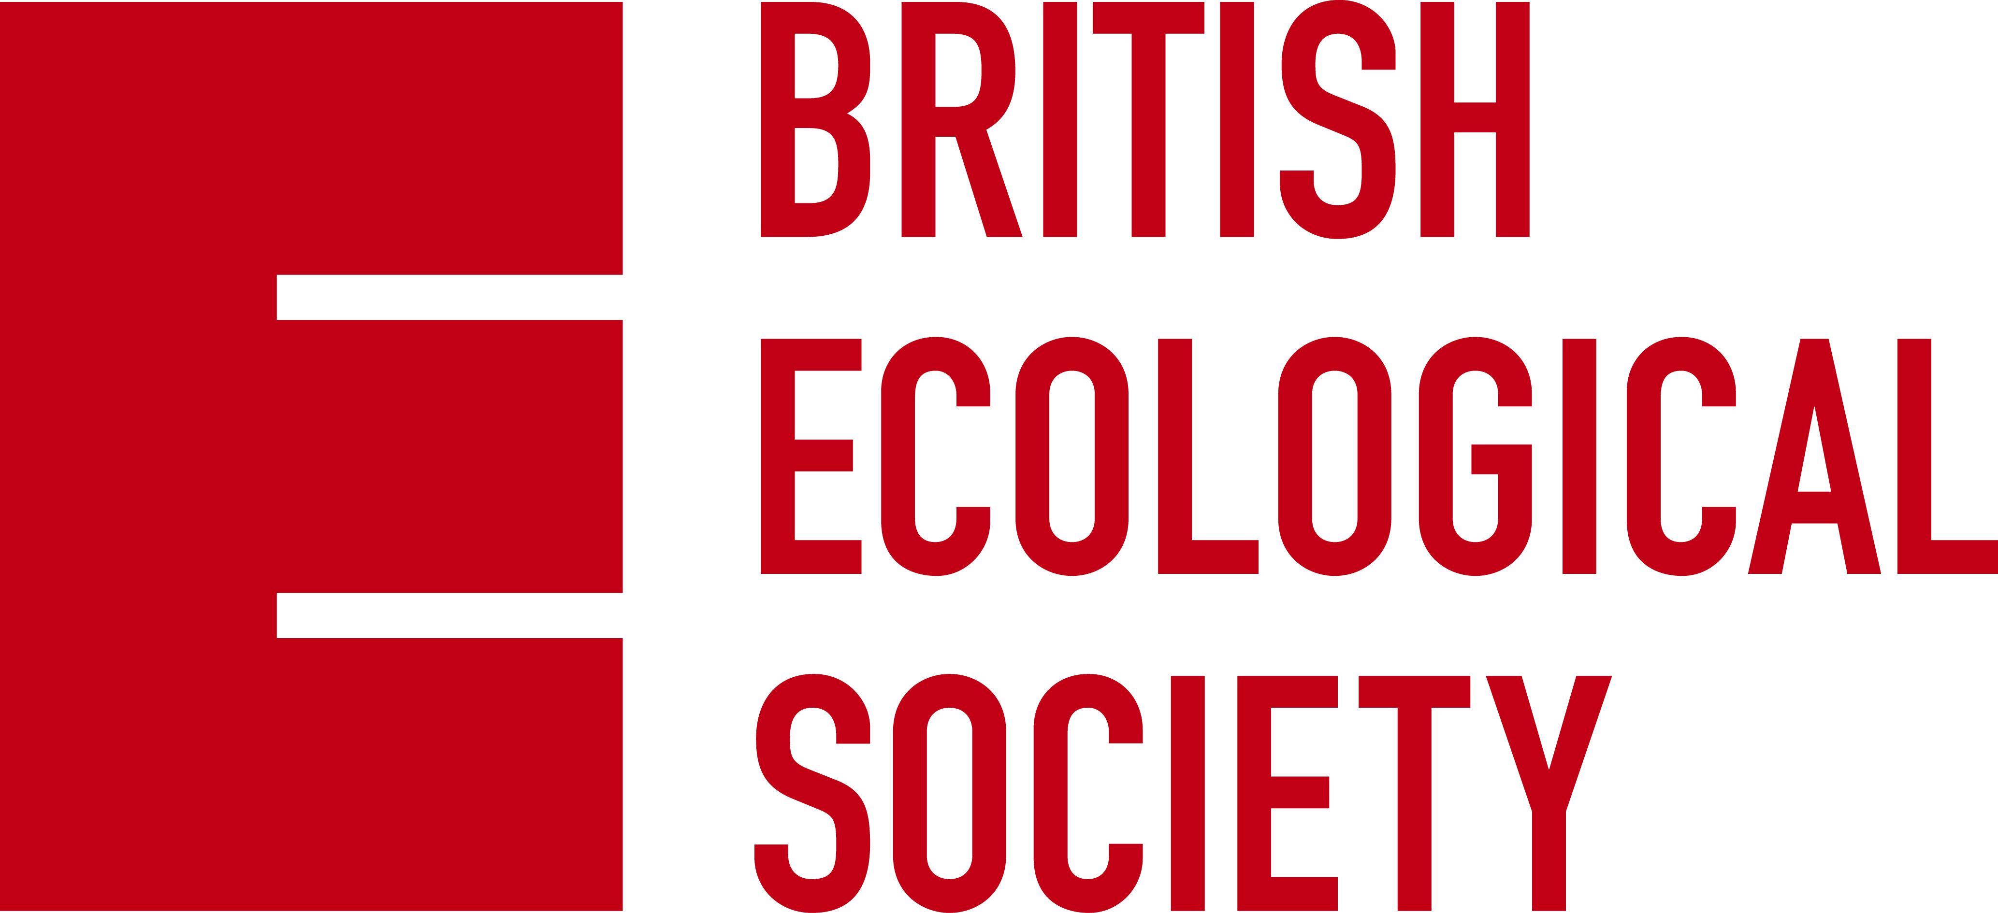

POSTER SCIENCE COMMUNICATION COMPETITION – UP GOER FIVE

Are you interested in science communication? Do you want to explain your research to non-scientific audiences or people outside of your field? Then here is your chance! Using the incredibly successful Up Goer Five initiative, we would like to invite you to summarise the research conveyed on your poster using just 250 of the thousand most common English words.

Type your 250 words into the A4 sheet provided below, print it out and stick it with your poster at our Annual Meeting. All entries should include a title in bold and we recommend using Calibri font in size 18. This a people’s choice award, so delegates at the meeting will vote by ballot! The winner will be announced at the meeting.

Please feel free to tweet photos of your Up Goer Five poster using #upgoBES.

Theo Sanderson has created a useful website to check whether you are using those most common words. The inspiration for this new initiative has come from xlcd, Theo Sanderson and Chris Rowan & Anne Jefferson. For more information on how Up Goer Five has been used before, please read Christopher Lortie and Dr. Holly Menninger’s blog.

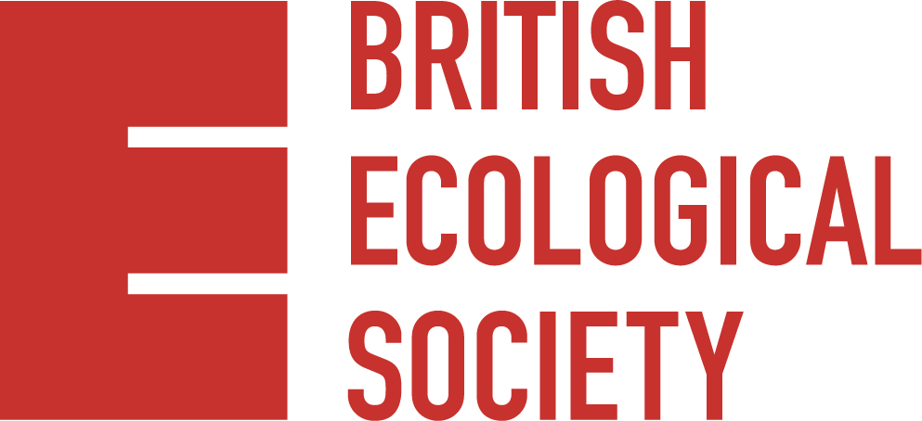
#upgoBES
#BES2016
Please type synopsis here…

