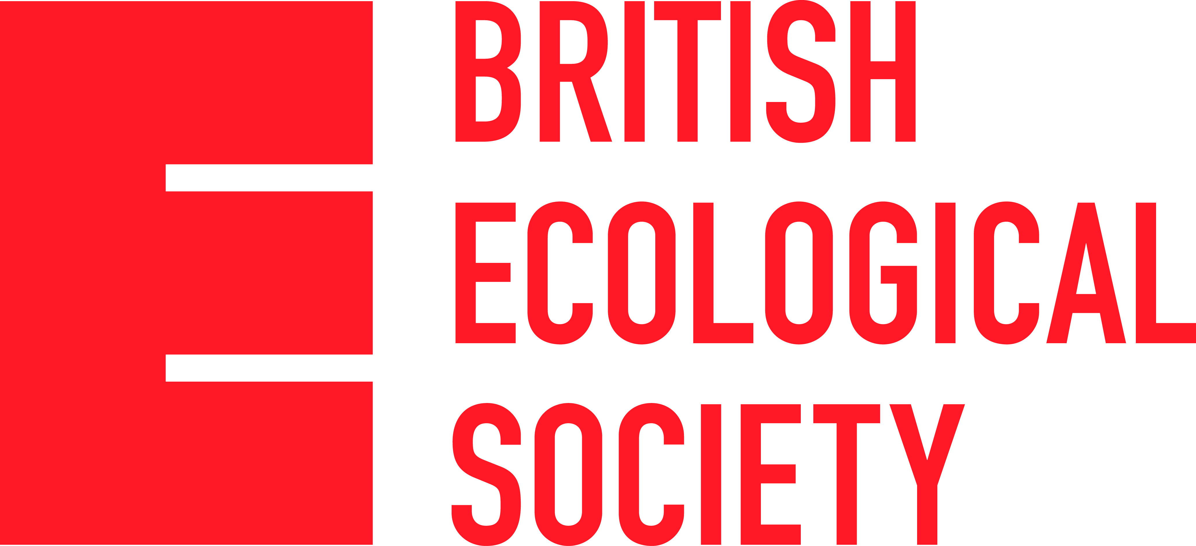

Equality and Diversity Monitoring Form

We are committed to promoting a community of ecologists which is as diverse as possible. A more varied pool of people will maximise talent, allowing ecology to grow and evolve over the next 100 years. We seek to overcome the barriers to career progression at all stages and work to address areas such as – but not limited to – disability, ethnicity, gender, sexuality and socio-economic status.
A key step in this process is data collection, so we hope you understand why we ask for this information. All questions are optional.
The BES acknowledges that this information is of a confidential nature; it will remain confidential and will only be used to produce anonymised statistics on equality and diversity. Acceptance of any grant applications, meeting abstracts or journal submissions will not be influenced in any way by completing this section.

Year of Birth
…………………………………………

Gender
Female □
Male □
Other □
Prefer not to say □

What is your sexual orientation?
Bisexual □
Gay Man □
Gay Woman/Lesbian □
Heterosexual/Straight □
Other □
Prefer not to say □

Country of Origin

………………………………………………………………………………..

What is your Ethnic Group?
Collecting ethnicity data from a global audience can be problematic due to the sheer number of ways different groups within a populations define themselves. We realise that the categories below are very broad but please select the option you feel is most appropriate from the list below:
Asian □
Black/African/Caribbean □
Latino/Hispanic □
Mixed/Multiple Ethnic Groups □
White □
Other Ethnic Group (Free Text Box) □ Please specify…………………………………………………
Prefer not to say □

Disability
The equality act defines a person to be disabled if they suffer from a physical or mental impairment which has significant or long-term detrimental effect on their day-to day activities.

Using this definition, do you consider yourself to be disabled?
Yes □
No □
Prefer not to say □

