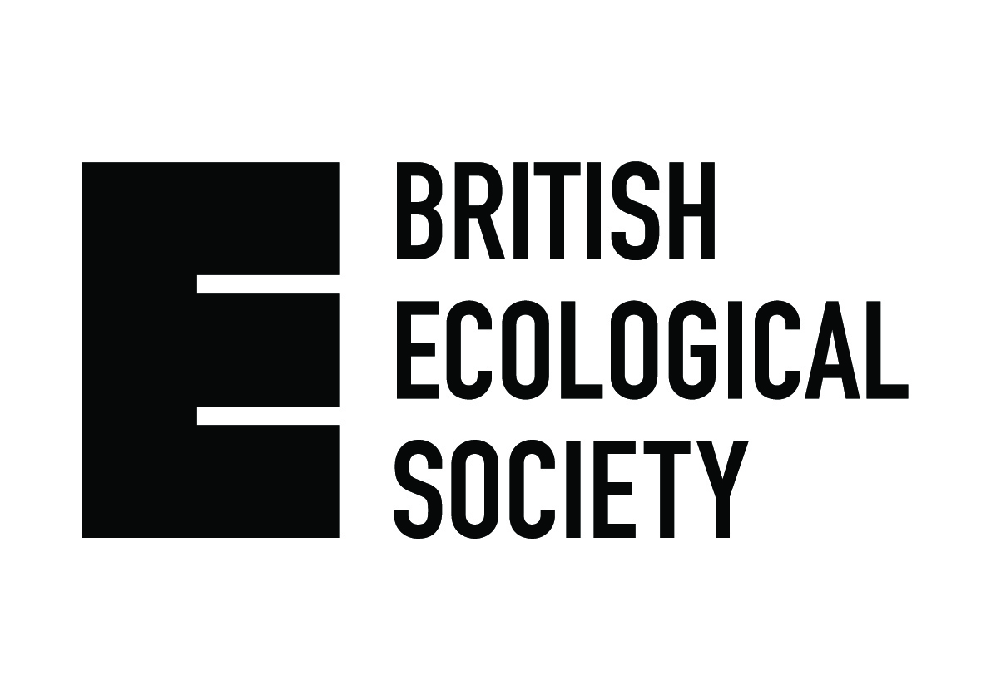

Public Engagement funding application

Application Notes
- All financing provided by the British Ecological Society (BES) requires that the applicant is a member of the British Ecological Society.
- To apply for funding to undertake public engagement activities, please complete this form and return it, via email to chrisj@britishecologicalsociety.org.
- Completed applications will be assessed on merit as per the associated guidance notes which can be found online.
- A maximum of £1,000 will be given to any one applicant in a given year.

Applicant Details
Applicant name: |  |  |  | BES membership number:
Organisation: |  |  |  | Department:
Email Address: |  |  |  | Career stage:

Project Details

Project title
Activity name (if part of a larger event)
Activity date
Objectives | 1.  2.  3.
Intended audience:
Proposed activity:
How will your activity engage your intended audience?
How will you measure if your engagement was successful?

Finance Details
Amount requested (max value £1,000)
Please provide a detailed cost breakdown:
Is this match or partnership funding?
Name of partner organisation:
Organisation contact name:
Organisation contact details:

Submission

Please sign your completed application form and email to chrisj@britishecologicalsociety.org

If a student application please also ensure the application is signed by a supervisor

Applicant signature: |  |  | Date:
Supervisor signature (if applicable): |  |  | Date:

