Task: Nature Diary
Nature Connectedness focuses on the relationship between people and nature. One way of developing a strong connection with nature is by taking time each day to notice three good things in nature. Try writing your nature diary below!
Try writing your ‘three good things’ in a nature diary like the one below!
 | 3 Good things in nature | How did this connection with nature make you feel?
Day 1
Day 2
Day 3
Day 4
Day 5
Day 6
Day 7
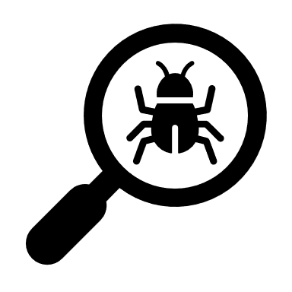
Q: Why is reconnecting with nature important to you?
Q: What benefits do you think a connect to nature would bring if more people did it?
Extension: Can you use your ‘three good things’ in nature ideas to write a poem or story?

Task: 5 pathways to nature connection
Connecting with nature can help us look after our mental and physical wellbeing. Use the pathways below to devise your own pledges to strengthen your connection with nature.
The pathways below are inspired by the ‘5 Ways to Wellbeing’: https://findingnatureblog.files.wordpress.com/2019/10/pathways-nature-connectedness-postcard-a5.pdf
What will you do for each of the following pathways?
Pathway | In the next 2 weeks… | In the next year…
Senses
tuning in to nature through the senses
Emotion
feeling alive through the emotions and feelings nature brings
Beauty
noticing nature’s beauty
Meaning
nature bringing meaning to our lives
Compassion
caring and taking action for nature

Task: Urban wondering - how can I find nature in my local area?
It can hard to spot nature sometimes. Urban wondering can help us explore a familiar place, but in an unfamiliar way. Use the cards below to help you explore. For example, start by following a smell! Flip a coin to decide the way to go – heads for left, tails for right!
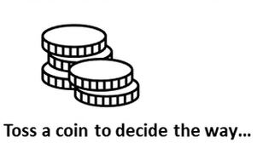
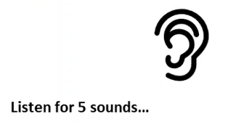
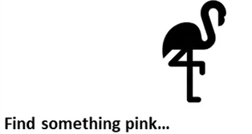
Task: What is Tidy Wild?
After watching the Parks & Gardens NatureCast, what were some of the top tips for designing parks and gardens with ecology in mind?
1.

2.

3.

4.

5.

6.

Use the space below to get creative and design your Tidy Wild space. This could be a section of garden, balcony or a single window box.

Q: How could you investigate the impact of your own Tidy Wild intervention?
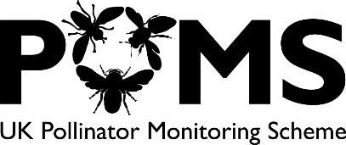
Task: Counting pollinators
Many wild plants and those we rely on for food depend on insects to pollinate their flowers. Successful pollination leading to plants making seeds and fruits. Many scientists are worried that pollinating insects such as bees and flies may be declining in numbers. To be sure, we need more data to to see how many insects there are across the country and how this changes over time!
The Flower-Insect Timed Count (FIT Count) is a nationwide scientific study designed to collect new data on numbers of flower-visiting insects, as part of a wider set of surveys under the UK Pollinator Monitoring Scheme (PoMS).
Task: Use the boxes below to record the method for the FITCount. You can use the NatureCast video and https://ukpoms.org.uk to help.
1. | 2. | 3.
4. | 5. | 6.
You can use the free ‘FITCount’ app on your phone to collect and submit your data. Alternatively we have put paper copies of the recording sheets below. Don’t forget to submit your results! For more information and helpful guides on the FITCount, visit https://ukpoms.org.uk

