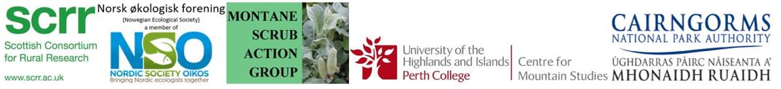
BES/NØF Symposium: Treelines and Beyond
3 - 4 September 2018
Abstract Submission
We are inviting submissions for short talks and posters for the Norway part of the above Symposium. To submit an abstract, please complete the below form and return to Amy Everard by 17:00 (BST), Friday 27 July.
By providing the below information you are agreeing your data can be used to contact you regarding presenting at this conference. This information will be used in the conference programme if your abstract is accepted.
Name:
Institution:
Email:

Please select which session you are submitting to:
TALK: Treeline dynamics
TALK: Consequences of treeline movement
TALK: Conservation considerations
POSTER: Open Session
If you are submitting a poster, please select whether or not you wish to be considered for the Student Poster Prize:
YES
NO

Abstract Title:

Abstract (150 words maximum):

