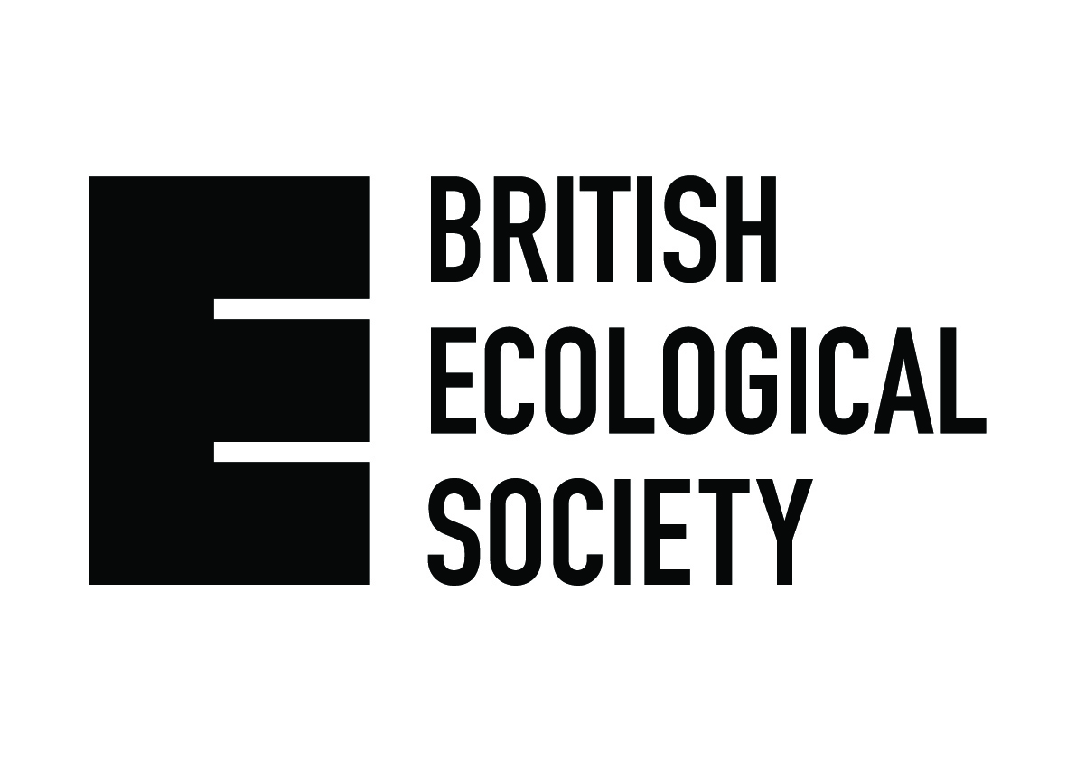

Public Engagement Regional Funding Scheme

Application guidance and Terms & Conditions

To be eligible for funding applicants must be members of the British Ecological Society. All applications must be submitted via email to jessica@britishecologicalsociety.org

Aims of the Public Engagement Regional Funding Scheme

- To engage audiences with ecological research and increase the number of opportunities for members of the public to be actively engaged with ecology
- To support BES members in piloting new activities and to take advantage of public engagement opportunities
- To support the wider BES strategy of sharing ecological research with wider audiences and discussing ecological issues with non-specialists

Eligibility

The BES Regional Public Engagement Fund is open to any BES members. It is a requirement that any successful application includes one or more researcher actively involved with ecological research.

We are not able to accept applications that are:
- From individuals that are not based in the UK
- For projects whose target audiences are not primarily UK residents
- For projects where the target audience is school children

Previous applicants:
We are happy to receive applications from previous applicants whether they have been successful or not. Previous successful applicants must submit evidence of evaluation and feedback gathered from the previous project to support any subsequent application.

Funding criteria

Please ensure you provide a detailed cost breakdown on the application form.

What we won’t fund:
- Activities undertaken by individuals already in paid employment, where such activities would be reasonably undertaken as part of normal duties
- Bids for expensive equipment
- Projects where it is clear the whole project would go ahead without BES funds

Payments will be made by BACS transfer only, therefore successful applicants will be asked to submit their bank account details to enable processing of payments.
Processing may take up to 1 month, therefore please allow time for payments to be made before committing funds.
At the end of the project successful applicants are required to submit evidence of expenses incurred.

Success criteria

Successful applications must demonstrate that:
- The objectives of the project are clearly identified and are achievable
- The intended audience is identified with appropriate consideration given to the location of the proposed activity
- Delivery of the project will clearly assist in meeting the objectives defined
- Due consideration has been given to the evaluation strategy for the project
- Projects proposals are cost effective – those which are likely to have a large impact in relation to their cost are more likely to be funded
- The project can realistically be delivered within cost and time constraints

How awards are judged

On receipt, applications will be reviewed by members of the Public Engagement Working Group and require approval from at least two members to be awarded. In deciding whether to fund your application, we will consider if the project meets the overall aims of the fund and associated success criteria (see above).

We will inform you of our decision within 4 weeks of receiving your application.

If your application is funded, we will send you a short form for you to complete at the end of the project, asking you to reflect on how it went. Completing this form and providing photos of the event are a requirement of accepting the funding and will enable us to publicise the event on the BES website.

