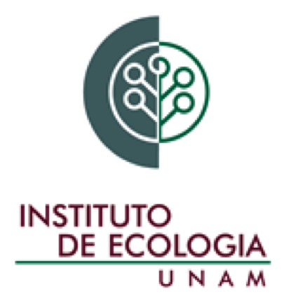

Instituto de Ecología
2019

The Universidad Nacional Autónoma de México (UNAM) invites applications to fill a tenure-track Assistant Professor position at the Departamento de Ecología Funcional, Instituto de Ecología.

The successful candidate will be required to develop an independent research program on plant ecophysiology. It will be expected that she/he develops collaborations, primarily but not exclusively with members of the Department of Functional Ecology and lecturing regularly at undergraduate and graduate levels is compulsory.

Candidates should hold a PhD in Biology or Ecology and have a background in ecophysiology integrating different levels of organization to understand the interactions between plants and the environment. We will consider candidates with a strong publication record (> 10 high-impact peer-reviewed papers in the relevant area and ponderable in terms of participation), a track record of securing competitive funds, and with verifiable experience teaching and supervising students. Fluency in Spanish to perform lecturing and having less than 37 years of age is a requirement. This is part of a University program to rejuvenate the academic workforce, hence youngest candidates will be favored.

Selection will be based on 1) the strength of the candidate’s Curriculum vitae, 2) a written research proposal (less than 10 pages) to study plant ecophysiology, 3) a brief outline of the research activities for the first year including teaching and student supervision, and 4) a two-page proposal for the following 3 years outlining how the candidate is planning to increase the scientific and social impact of his/her research project.

The application should include a letter addressed to the director of the Institute, Dr Constantino Macías Garcia stating the candidate’s reasons to apply, the Curriculum vitae, a brief description of current and future research interests, the documents indicated in numbers 2 to 4 (above), a copy of the PhD title, a copy of birth certificate, and the documents supporting the CV (only the first page of published papers, letters/e-mails indicating that papers have been accepted for publication, and evidence of teaching and thesis supervision).

All documents should be sent electronically as a single PDF file to secacad@iecologia.unam.mx. The closing date is July 23, 2019. Shortlisted candidates will be required to send the documents by post to: Instituto de Ecología, UNAM, Ap. Postal 70-275, Ciudad Universitaria, Ciudad de México, CP 04510, México.

Dr. Juan Fornoni
Secretario Académico
Instituto de Ecología, UNAM

