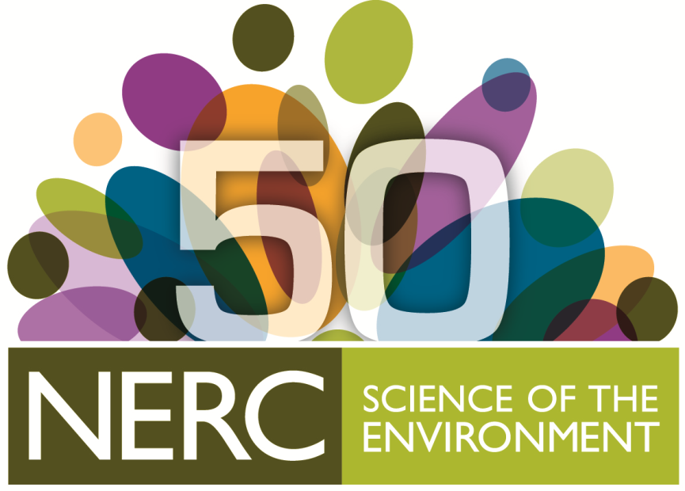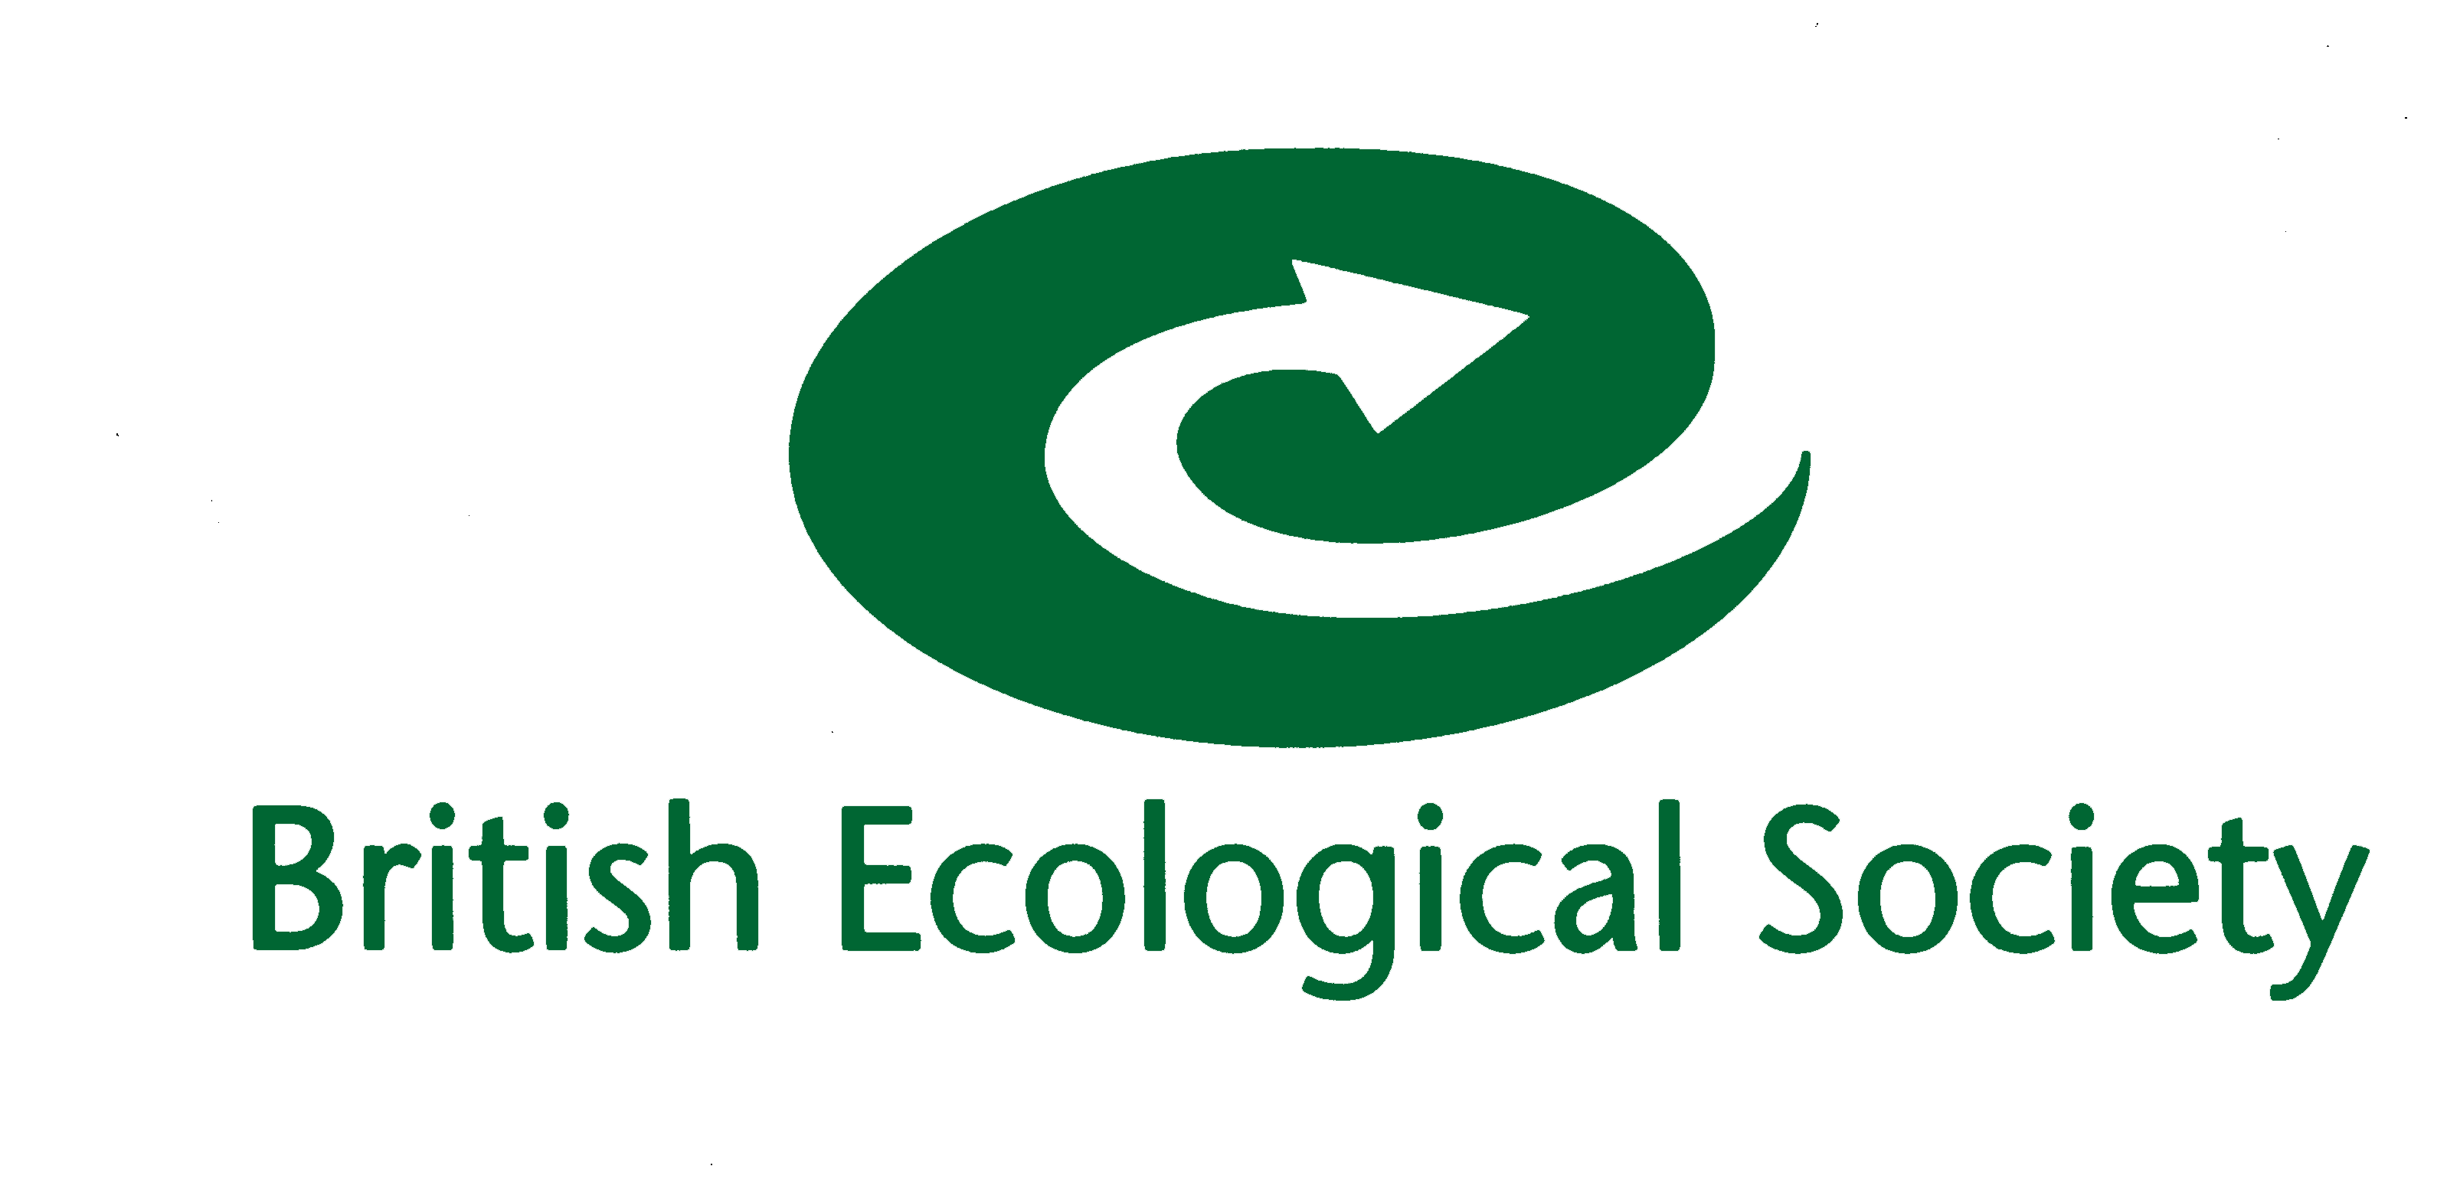

Science Communication Training

SCIENCE COMMUNICATION TRAINING FOR RESEARCHERS
13th FEBRUARY 2015. 10.00am-16.00pm
CHARLES DARWIN HOUSE, LONDON.

The BES is planning to attend a number of music festivals in 2015 and we are looking for researchers / PhD students wanting to get involved to contribute and develop their own ideas to take on the road.
Read more about our previous programme: What we did in 2013
Science communication training:
Thanks to the support of NERC, we will be hosting a training day on 13th February 2015 for anyone wishing to get involved. The day will include science busking training provided by Science made Simple followed by workshops designed to develop ideas for various festivals.
There is no charge to attend the training but please note places are limited to 25 and we therefore ask anyone interested in attending to return this form to Karen Devine no later than 9.00am Friday 6th Feb. We will confirm places by 3pm on the same day.
Name
Institution
Are you….. | PhD student | Other (please state)
Email
An activity you would like to develop (<100 words)
What is the ecological message you are hoping to communicate (<100 words)
Availability: We are still waiting for final confirmation on one festival proposal. We would therefore be grateful if you could confirm your provisional availability for May 29th-31st and June 24-28th
Yes/No

